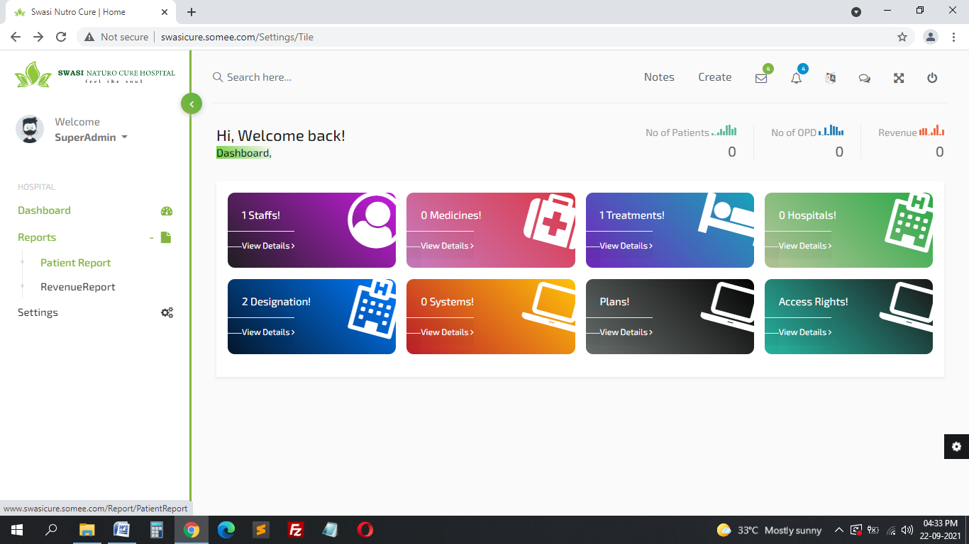**Reports**

Reports:

1. PATIENTS REPORT – (Based on **From & to Date**)

Personal Information

* 1. S. No
  2. Date
  3. CR. No
  4. Name
  5. Mobile No
  6. Health Issue
  7. Consulting Doctor add new column

OPD Details

1. S. No
2. Date 1 & Treatment Name & Therapist Name
3. Date 2 & Treatment Name & Therapist Name (If they come 16 Treatments need to show it)
4. OPD REPORT – (Based on **From & to Date**)
   1. S.No
   2. Date
   3. CR No
   4. Name
   5. Phone No
   6. Treatment
   7. Therapist Name Add New Column for (Therapist name in OPD)
   8. Treatment Payment
   9. Medicine Payment
   10. Mode of Payment
5. MEDICINE REPORT (Based on **From & to Date**)

Purchase Details Master Data

* 1. S. No
  2. Date
  3. Medicine Name
  4. Purchase Rate
  5. Current Stock (Balance Sale count)
  6. Purchase Count
  7. New Stock

Sales Details (OPD Prescription)

* 1. S.No
  2. Date
  3. Patient Name
  4. Mobile No
  5. Medicine Name
  6. Quantity
  7. Rate
  8. Mode of Payment

1. Revenue Report (Based on **From & to Date**)

***Income***

* 1. S. No
  2. Date
  3. CR No
  4. Name
  5. Treatment
  6. Amount Paid
  7. Total Amount

***Expense***

* 1. S. No
  2. Date
  3. Purpose of expense
  4. Description
  5. Amount
  6. Total Expense
  7. Approved From

Need Clarification

**Plan**

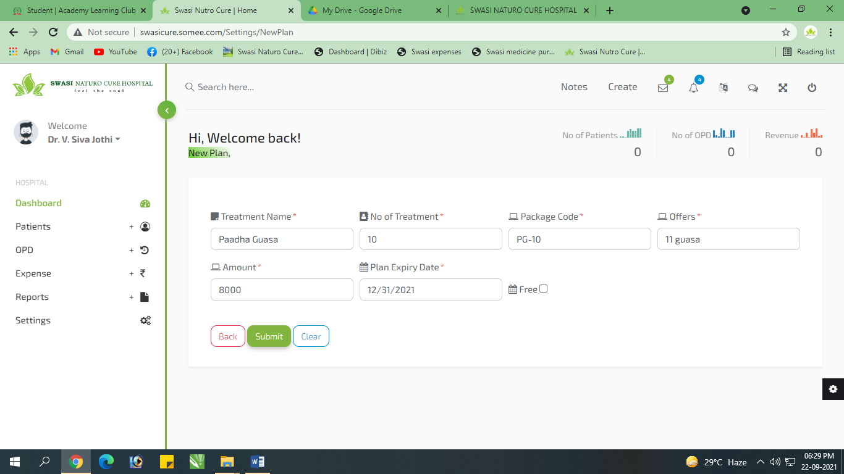

Free – Check Box iruku But Need Text Box… Athula ethachum oru Treatment or Medicine Free ah kudupom atha mention pananum.. Fixed

**Dashboard**

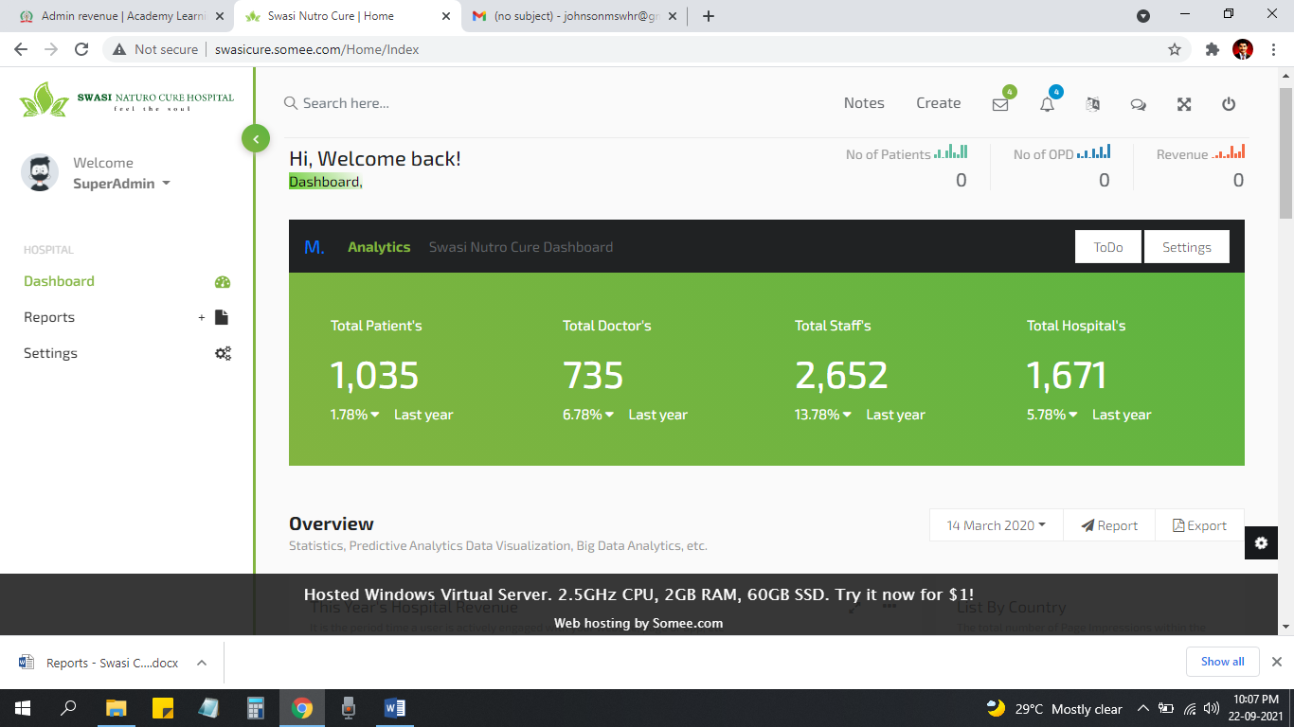

Inga Dashboard la Datas venum.. **(Hospital wise check panrathuku dropdown vachu atha view panra maari venum) -- Need Clarfictaion**

1. No of Patients (Current Month) - fixed
2. No of OPD (Current Month) fixed
3. Total Revenue (Current Month)

**Dashboard**

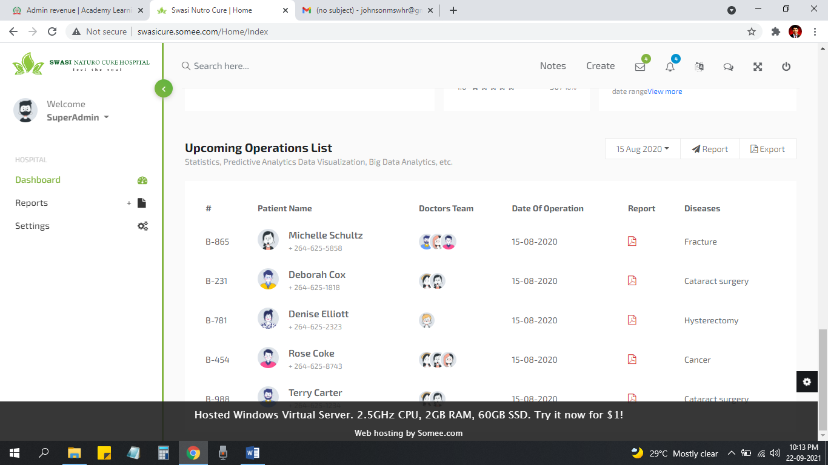

Appointments Add pana option venum… **But No urgent…**

1. Date
2. Name
3. Phone No
4. District
5. Reason for Appointment
6. Doctor Name(Expecting Doctor)

**Roles & Permission**

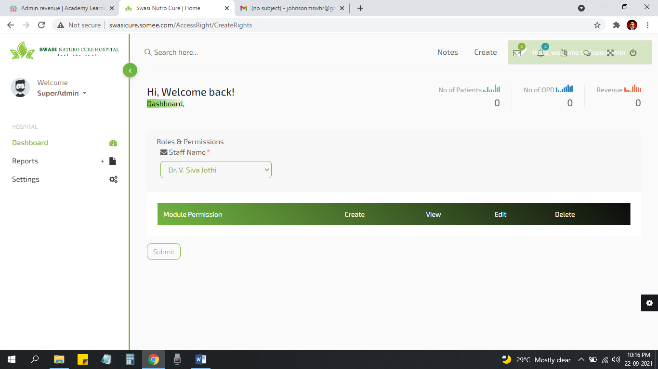

Functionalities Add panalaya da Add Panniyachu but need to time refer bellow screen short

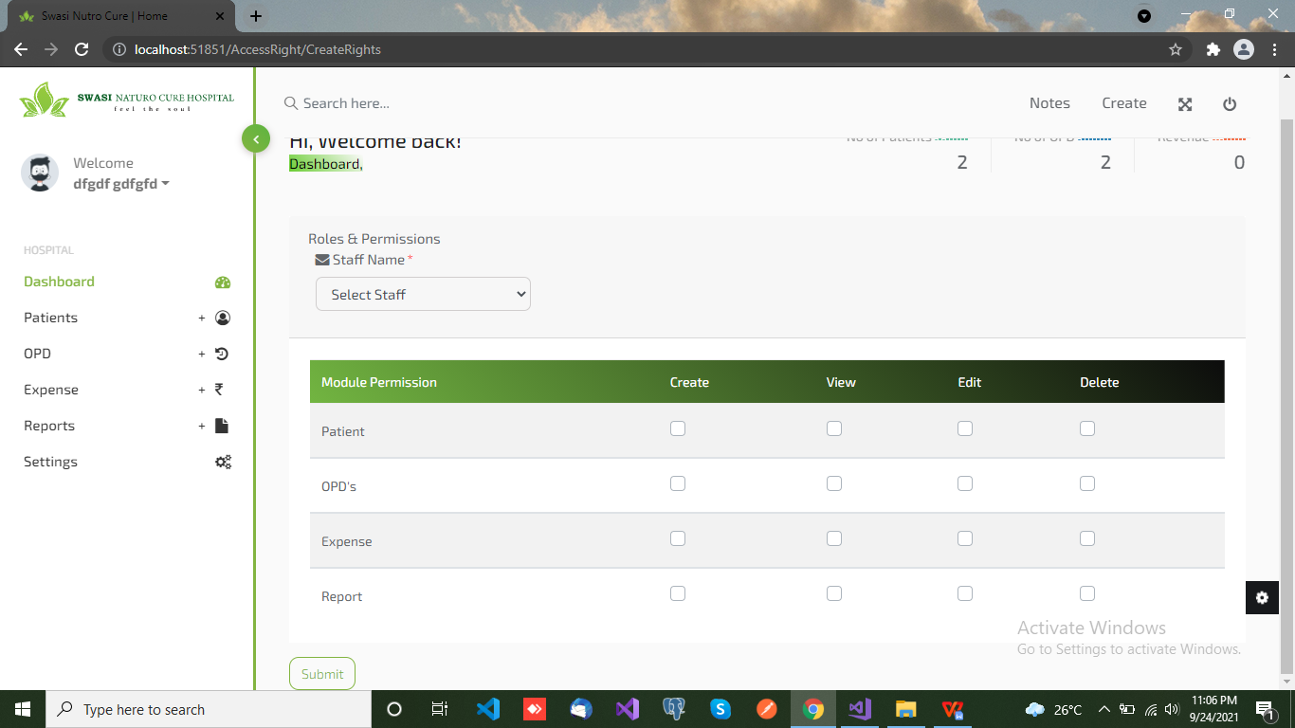

**New Hospital**

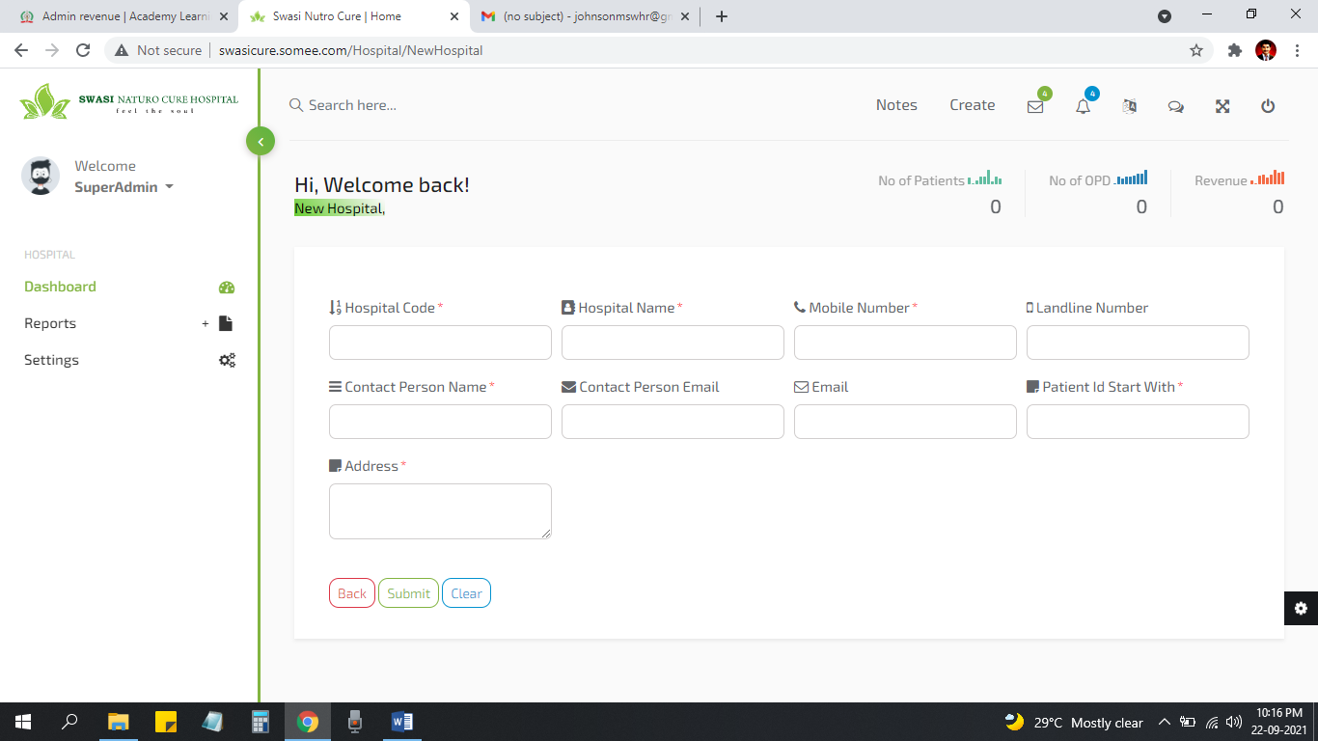

Hospital Code la Niraiya Characters add panrathuku option venum… Fixed Max 20 char

**New Treatment**

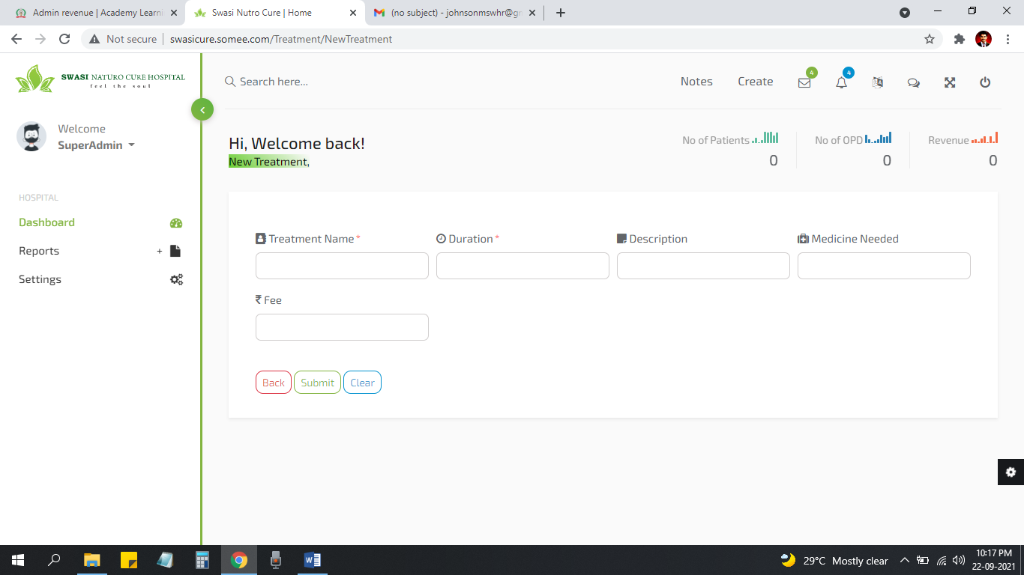

*Fee Mandatory Fixed

**New Drug**

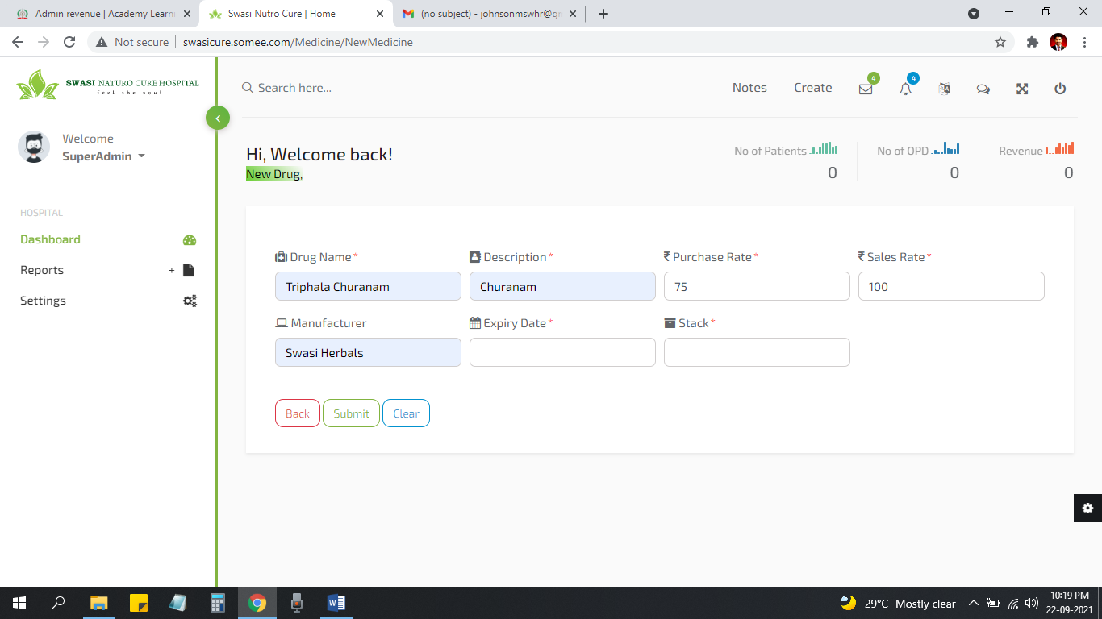

Stack No need Here… Fixed

**Designation**

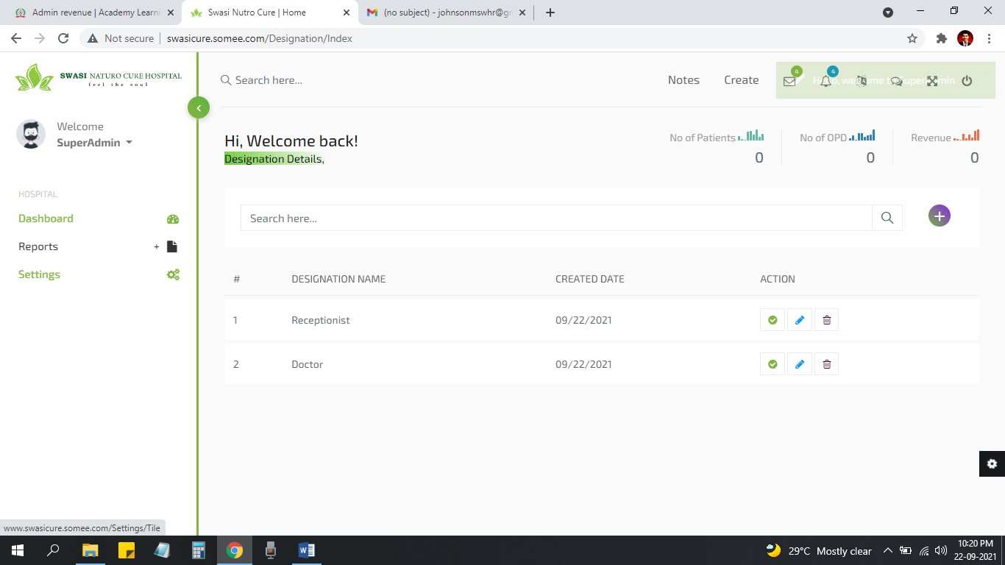

Ithoda Purpose ena User Creation Define Specific User Designation